**CST-391 Design Report Template**

|  |  |  |
| --- | --- | --- |
| **Milestone:** | Milestone 1: Project Proposal | |
| **Date:** | 11/12/2023 | |
| **Revision:** | 1.0 | |
| **Team:** | 1. Noah Funderburgh | |
|  | |
|  | |
|  | |
| **Weekly Team Status Summary:** | |  |  |  |  | | --- | --- | --- | --- | | **User Story** | **Team**  **Member** | **Hours**  **Worked** | **Hours Remaining** | | *As a develop, I need to create an ER diagram* | *Noah F.* | *1* | *0* | | *As a develop, I need to create upcoming user stories* | *Noah F.* | *1* | *0* | | *As a develop, I need to create a sitemap* | *Noah F.* | *1* | *0* | | *As a develop, I need to create a wireframe* | *Noah F.* | *1* | *0* | | *As a develop, I need to create a UML class diagram* | *Noah F.* | *1* | *0* | | |
| **GIT URL:** | *https://github.com/nfunderburgh/CST-391.git* | |
| **Hosting URL:** | None | |
| **Peer Review:** | *Yes* | We acknowledge that our team has reviewed this report, and we agree to the approach we are all taking. |
| **Loom URL:** | | None needed |

**Design Documentation**

**Description of Application**

The goal of the application is to create a place where users can submit their prayer requests and pray for others. Users will be able to look at a list of prayer requests as well as create, delete, and update their own prayer requests. Upon going to the website users will be required to login and or register if they don’t have an account. Once the user logs in they will then have to access the rest of the site.

**Required User Stories:**

[Tasklist .xlsx](https://mygcuedu6961-my.sharepoint.com/:x:/g/personal/nfunderbur_my_gcu_edu/EXiC_QwAhm9NkJF6HPUU4jEB-7tZ6B-nLGaBTP17g0GMfA?e=eTC8Nd)

**Initial ER Diagram**

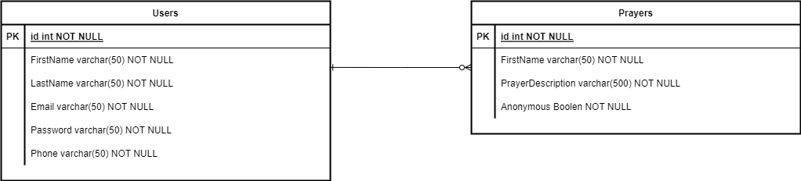

**Initial UI Sitemap**

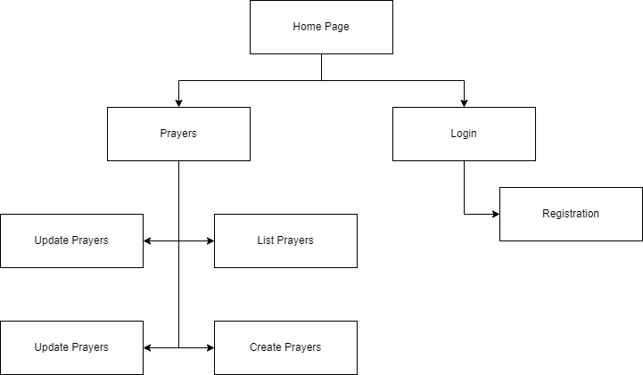

**Initial UI Wireframes**

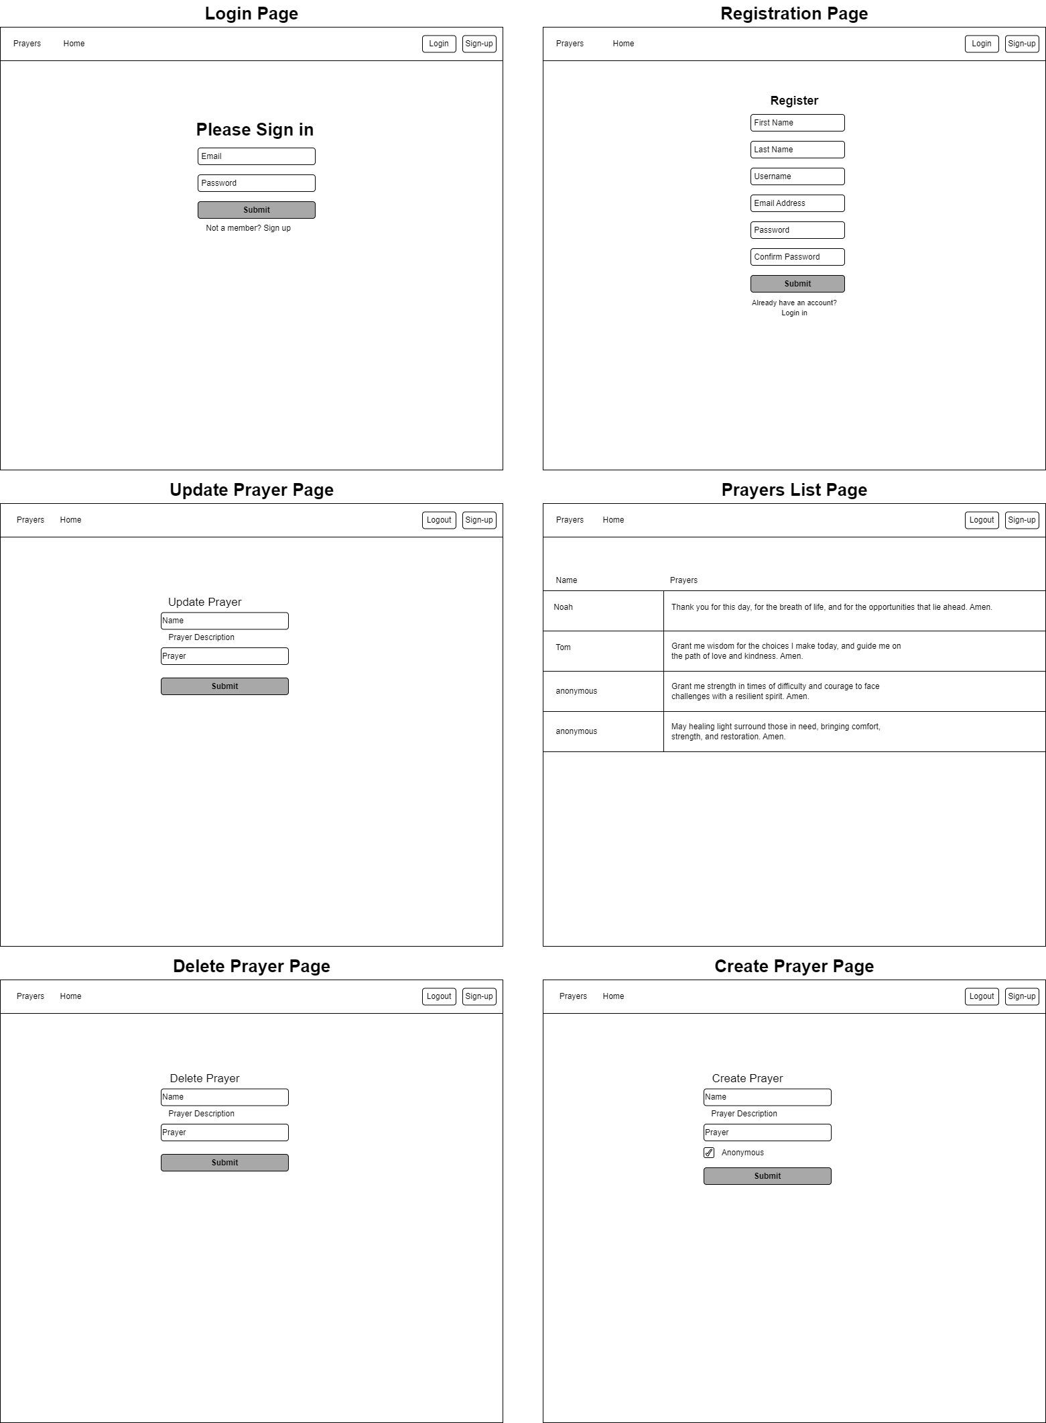

**Initial UML Classes**

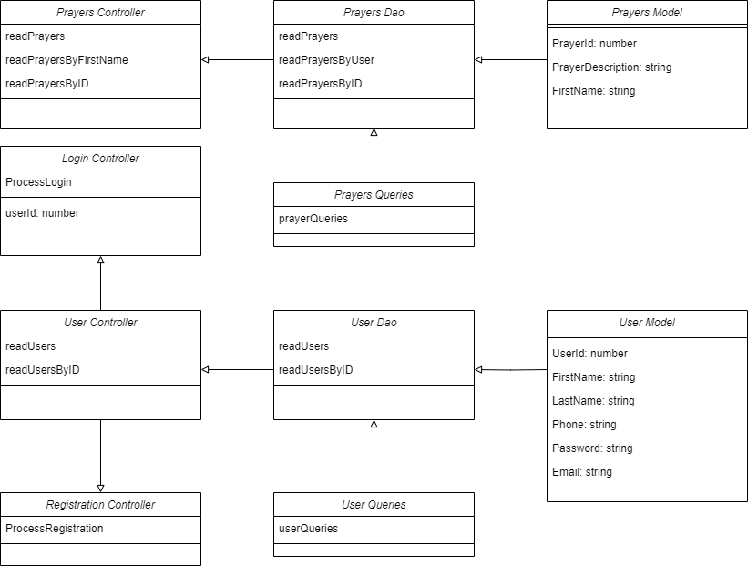

**Risks**

One of the major risks that stood out to me was privacy concerns with gathering and collecting users’ personal information. One feature I added to help combat is the ability to make the prayer request anonymous if they choose so. When users she other users’ prayer requests, they will only see the user’s first name, this is another feature for anonymity. Another potential risk is people’s diverse beliefs. Prayer is commonly used in many different religions so ensuring that the application is respectful and inclusive to people different beliefs is important to avoid *unintentional offense.*